Stageplan Rider «Le Phipou»
and other usefull and useless Informations about this artist.
Contact : +41 (0)079 596 75 93 Email: philippe.delacombaz@bluewin.ch Facebook : https://www.facebook.com/Le-Phipou-762981167414283

Some pic’s of the Equipment :

Equipement | Description
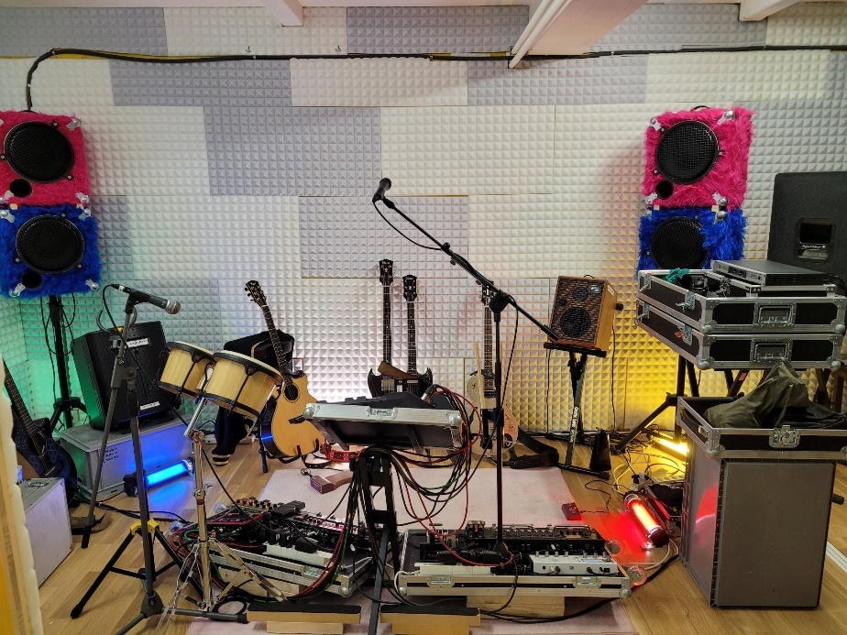 | - In Front of the whole Setup  - 4m large and 3m depth. Height minimum 2.10m  - Pink and Blue Speakers in the Back are the PA. If there is a PA-System at the Venue the 4m large can be changed to approx. 3m.
Equipement | Description
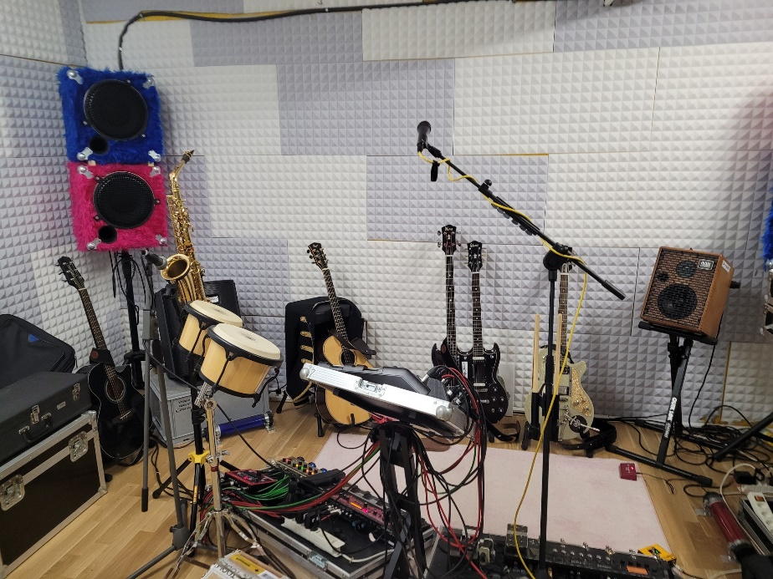 | - View with the Saxophone  - All Microphones are provided from « Le Phipou »  - One AC 230Volt Socket with minimum 10Ampere is required.
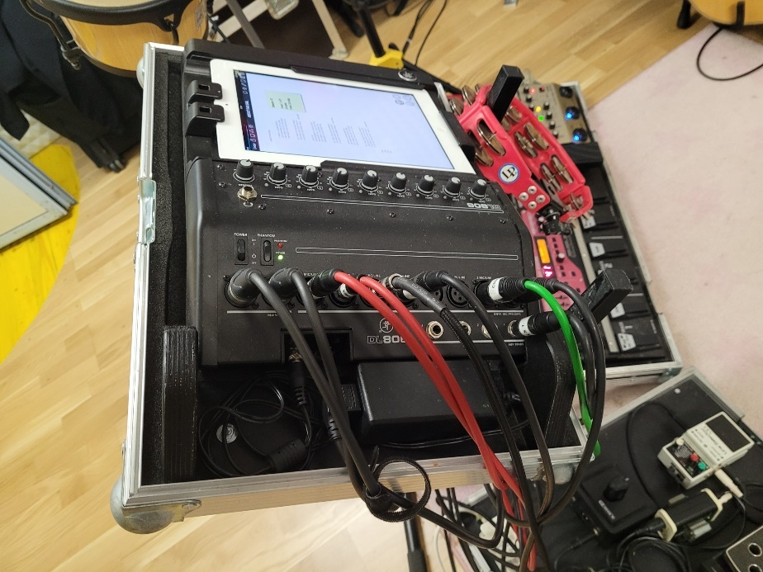 | - Mixer Mackie DL 1608  - 2 MONO Signals XLR  - All the Signals are comming on this two Paths
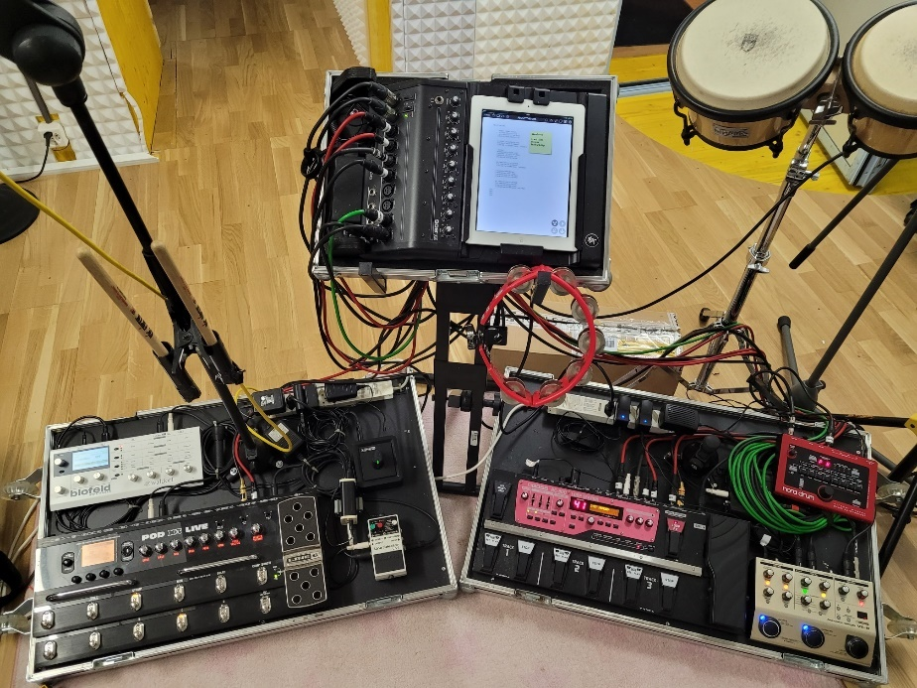 |  | - View on the Mixer and the Boards
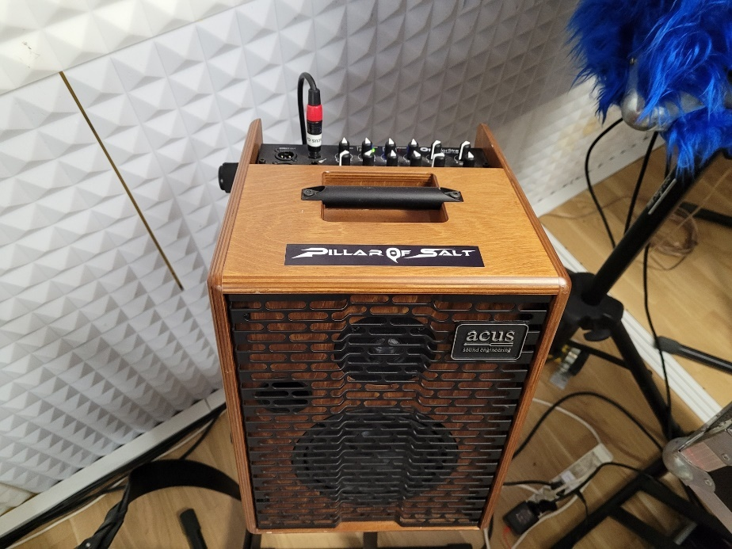 |  | - Acus is Guitar Amp and Vocal Amp.  - Direct XLR Out available
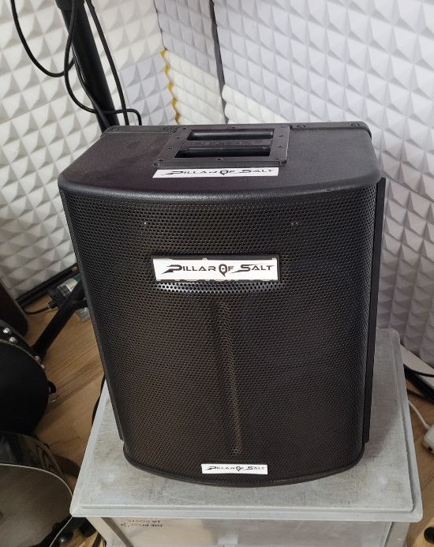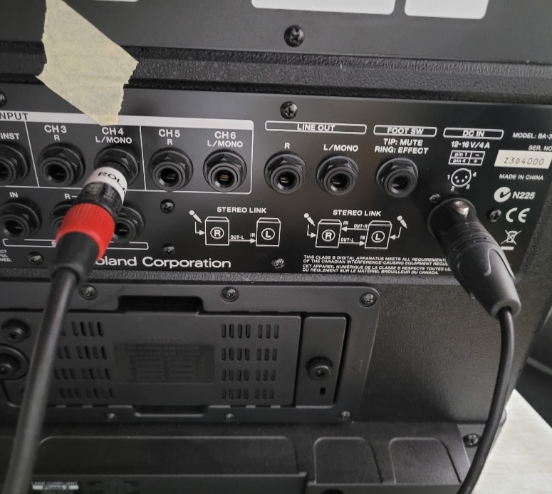 |  |  |  | - Roland BA 30  - Drum and Bassamp  - Line out Jack available
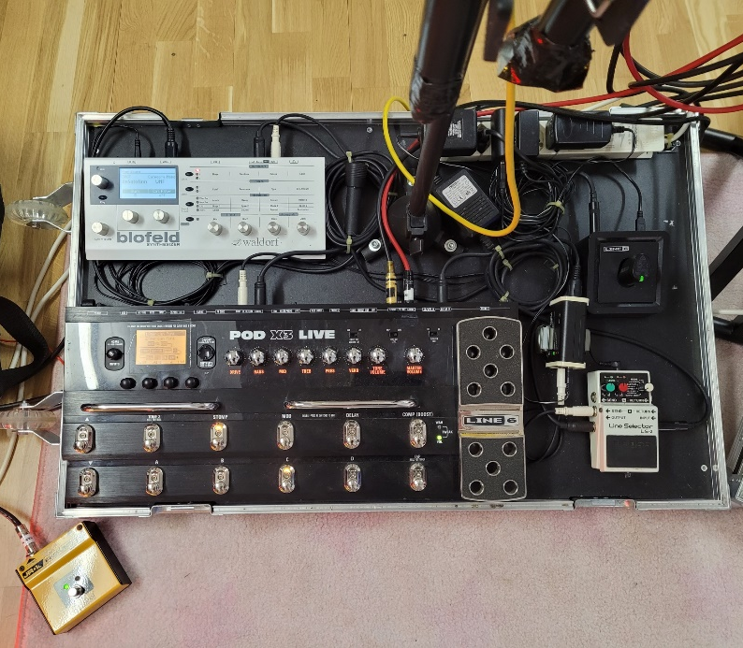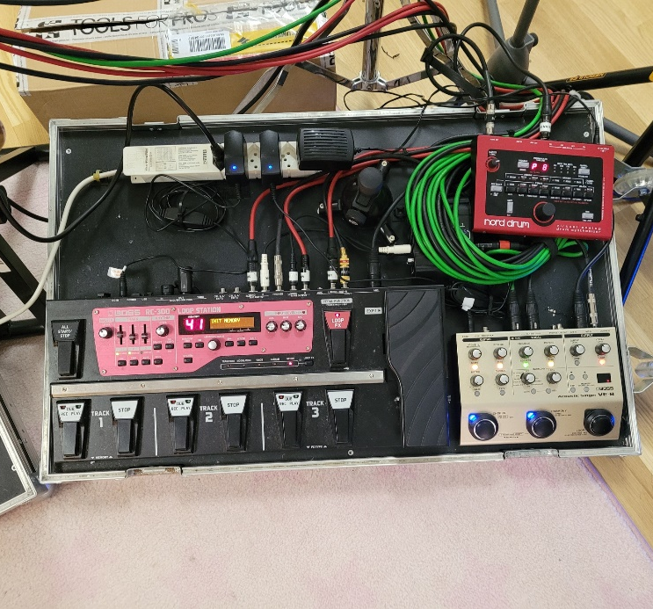 |  |  |  |  | Nice Pic of the two Boards.
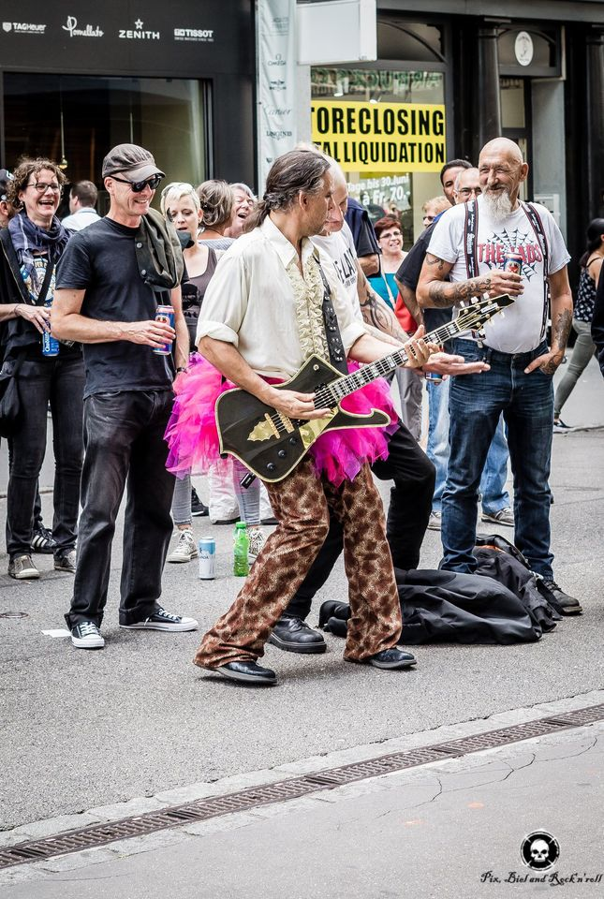 |  |  | Fantastic Picture of «Le Phipou» in the Crowd.

Stageplan Rider «Le Phipou»

For beeing most comfortable the required space is 4m x 3m as you can see on the Pic’s I need to move a lot between the Boards and Pedal’s
Two 230Volt AC Sockets would be great one is sufficent.
If desired « Le Phipou» is completely equipped with Sound and Light. The Sound Level is OK for Clubs and little Festivals. 50 to 200 people.

Channels for a PA and biger Venue
Channel Nr. | Signal | Remarques | Instrument
1 | Stage Mixer Mackie DL1608 | Mono Signal | All
2 | Stage Mixer Mackie DL1608 | Mono Signal | All
3 | ACUS | XLR Mono | Guitars and Vocals
4 | Roland BA 30 | Line Out Jack | Drum and Bass

